Learn Spark Streaming

what is Spark Streaming？
Spark Streaming is an extension of the core Spark API that enables stream processing of data streams.（出自官网）
Spark Streaming 是Spark核心API的扩展，具有可扩展、高吞吐量、容错性的实时流处理框架。
can be ingested many sources like , and can be processed using complex algorithms expressed with high-level functions like map, reduce, join and window. Finally, processed data can be pushed out to filesystems, databases, and live dashboards. In fact, you can apply Spark’s machine learning and graph processing algorithms on data streams.

工作原理
Spark Streaming receives live input data streams and divides the data into batches, which are then processed by the Spark engine to generate the final stream of results in batches.(出自官方)
Spark Streaming的接受端实时的接收数据并分割成段，然后交由Spark Engine产生最终的数据段，如下图所示。
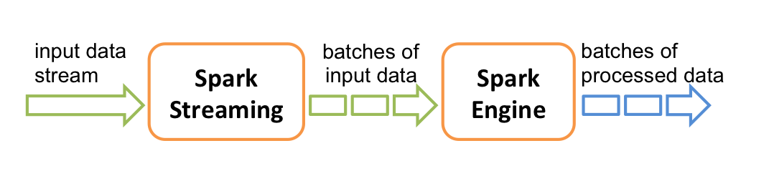

How to use it?
Spark Streaming provides a high-level abstraction called discretized stream or DStream, which represents a continuous stream of data.

